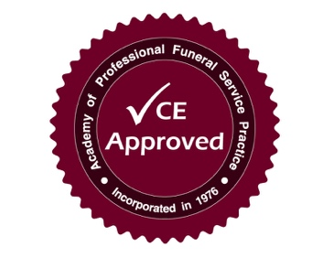
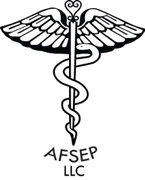
6 CEU’s including OSHA
All in 1 Day
Advanced Funeral Service Education Programs
3 Harrison Street
Norwood, New York 13668

6 CEU’s for Funeral Directors
Thursday, March 14, 2019
Holiday Inn Express
120 Laning Street, Southington, CT
Cost: $189/per Funeral Director

Agenda

8:30 a.m. – 9:00 a.m. Registration

9:00 a.m. – 10:00 a.m. Trauma and Healing
(1 CEU) Presenter: David R. Penepent, PhD, CFSP

10:00 a.m. – 11:00 a.m. Caring for Tissue Recovery Remains
(1 CEU) Presenter: David R. Penepent, PhD, CFSP

11:00 a.m. – 12 Noon Death Cafe (1 CEU) Presenter: Steven L. Johnson, MBA, CFSP

12:00 p.m. – 1:00 p.m. Lunch will be provided

1:00 p.m. – 2:00 p.m. The Funeral Director Celebrant
(1 CEU) Presenter: Steven L. Johnson, MBA, CFSP

2:00 p.m. – 3:00 p.m. Making the Funeral Real: Connecting People to their Own
Grieving Experience (1 CEU) Presenter: David R. Penepent, PhD, CSFP

3:00 p.m. – 4:00 p.m. OSHA (1 CEU) Presenter: Steven L. Johnson, MBA, CFSP
Register by Phone or Pay On-line at www.afsep.org _______________________________________________________________________
Or mail this bottom form with your payment to: AFSEP, LLC 3 Harrison St. Norwood, NY 13668
Southington – March 14, 2019 (585) 356-4929

Name: __________________________________ Address: __________________________________

City:_________________________________ State: ___________________ Zip: ________________

e-mail address:________________________________ Registration #:__________________________

